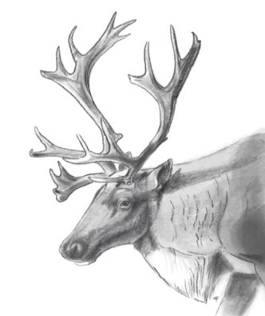

Meeting Minutes November 10, 2021

- Welcome- Heather

- Action Review – All

- Parsnip Analysis Continued – Scott/Sofia

EMP: caribou environmental mitigation policy - BC acknowledges the existing Peace Northern Caribou guidance documents are out of date and are working to consolidate into one document for future collaboration

Action Review
Apr. 14-May 12 | BC to respond to IMA, funding work plan, G2G (not being the mechanism BC wants for agreement) and Sec 11 – 7.2 MOU.  Update – on hold | Bryan W
June 23 | BC to draft a MOU (term sheet) ID headers, parameters, roles, and responsibilities – other provisions to be worked on together  - Will be ready for discussion for July 21st meeting – Did not occur. – on hold until Canada can participate  - Oct 27 update: BC and ECCC to draft a term sheet together prior to presenting to MLIB. BC and ECCC to draft prior to Nov 24th meeting. | BC (Bryan W)
Sept 15 | Funding 50,000 Stob 80 (Shared cost arrangement) in draft will have agreement in coming days.  MLIB (Lisa) to provide brief general overview of where money might be used (ethno/community meeting/etc.)  Linking to Scott’s work, linking to Parsnip LUP  Updates Oct 13:  Lisa will provide an overview to Loni  ECCC contribution agreement is being negotiated – Lisa and Agathe in conversations  Update Oct 28:  Lisa will provide overview at next meeting | Loni/Lisa
Oct 27 | David & Jim to have discussion with ministers regarding park management plan and get back to MLIB, | FLNRORD/ Parks
Oct 27 | David & Justin to discuss Parsnip approaches | FLNRORD

Parsnip analysis
- 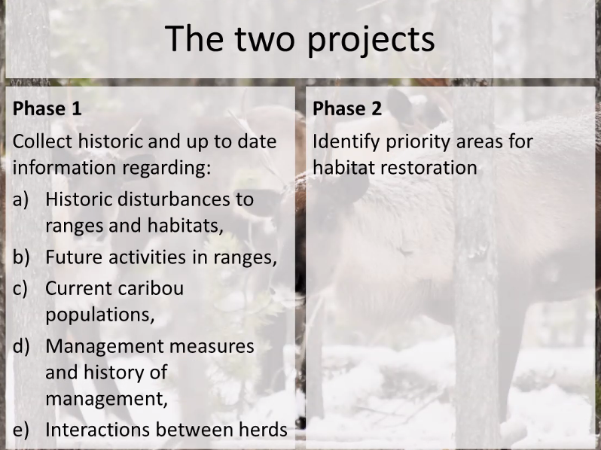
- 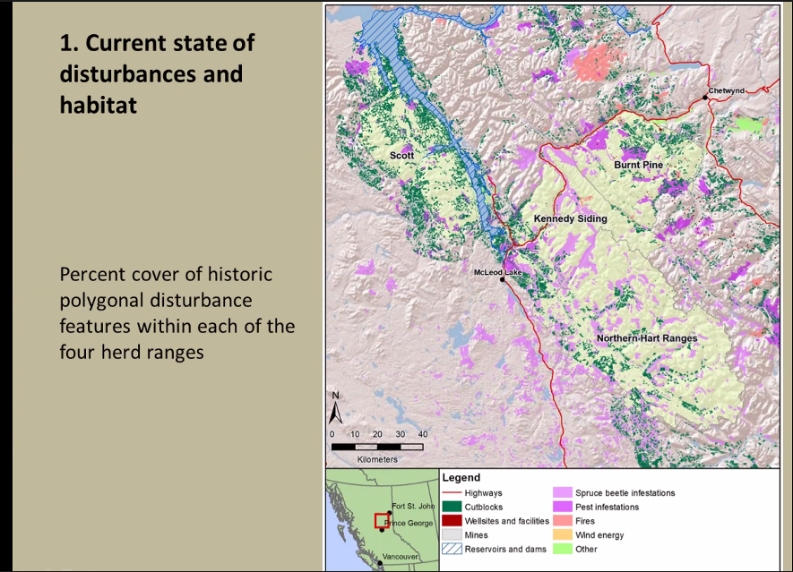
- 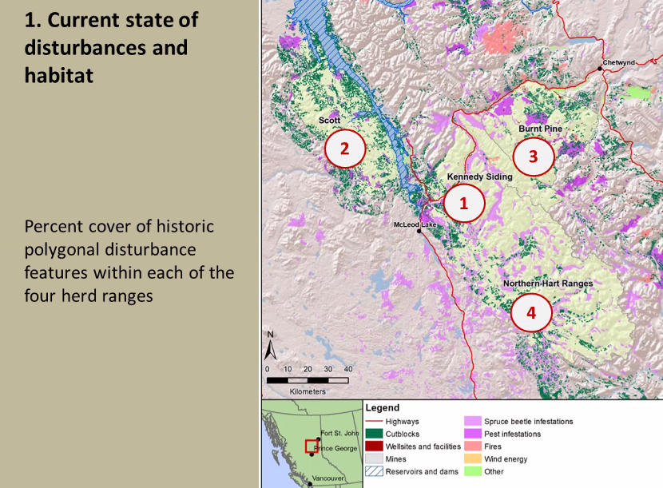
- 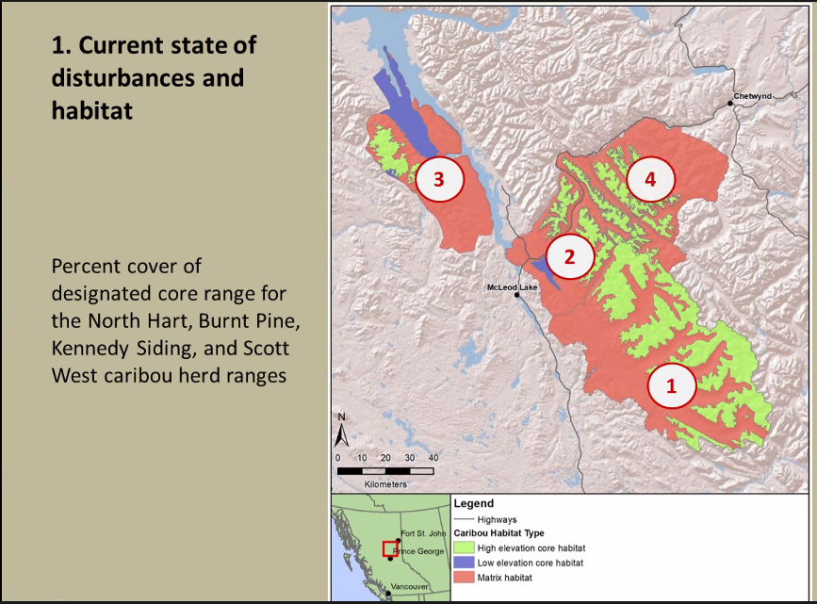
- 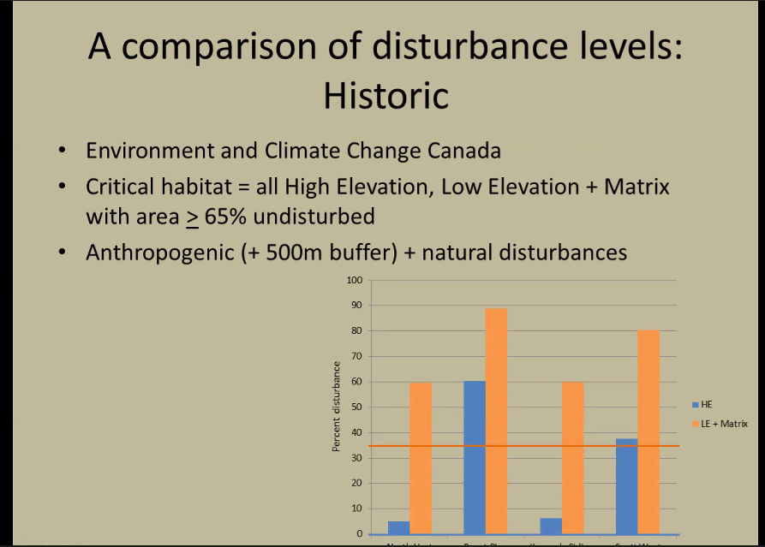
- Near term planned and permitted industrial activities
- 
 